7.3 Editors - 3D View - Sidebar
Introduction 1

Introduction
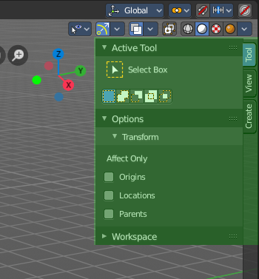
The 3D View is made of several areas. At the right side you will find the sidebar.

In the sidebar you will find tool settings and view related settings. And it is also the home of addons. The Create tab is already created by an addon. The Mini Lightlib addon, which is covered in chapter 7.3.13

The content differs, dependant of the chosen object and the current mode.

The Tools tab is also a special chapter. It contains the settings for the tools from the tool shelf.

